|  |
| --- |
| 新东方在线英语学习 |
| 新概念 1 册 |
| Lesson43-44 |



扫一扫。更多有趣的英语资讯。

# Lesson 43 单词讲解

1. of course: 当然

certainly 更加正式一些

Of course not. 当然没有。

1. kettle: n. 水壶kai dao
2. behind: prep. 在…后面

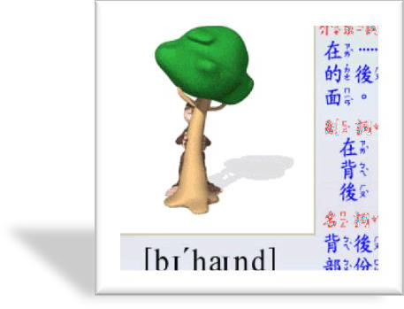

The boy is standing behind the tree.

1. teapot: n. 茶壶

hot pot, 火锅

1. now: 现在，此刻
   * 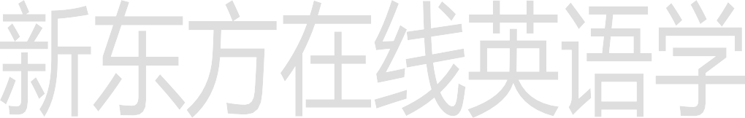What are you doing now?
   * I am learning English.
   * What are you going to do now?
   * I am going to swim.
2. find: v. 找到

Look! Can you see it?

Listen! Can you hear it? Look for it! Can you find it?

1. boil: v. 沸腾，开bu ao yi ao

The water is boiling.

boiled, 已经烧开的 Bu ao yi de

boiled water 开水boil: v. 煮

boil an egg

# Lesson 43 课文讲解

1. Hurry up! 快点

Be quick!

1. make the tea 沏茶

make some coffee 冲咖啡

make the bed 整理床铺

What make is it? 这个什么牌子的？

1. It’s over there. 就在那儿。

right here 就在这儿

1. Can you see it? Can you find it? look- see

listen- hear look for- find

1. There it is.

Here they are.

It is there.

They are here.

我到了。 Here I am.

他在那呢。 There he is.

# Lesson 43 语法讲解

可以吗? **can 用于任何人称**

Can you…? Can she…? Can he…? Can we…? Can they…?



你可以帮我吗？ **can + 动词,且原形！**

Can you help me? 他可以做这事吗？ Can he do it?

我们可以一起游泳吗？

Can we swim together? Can you make the tea? Can you see it?

Can you find them?

# Lesson 44 单词句型讲解

1. knife- knives
2. box- boxes
3. loaf- loaves
4. shelf- shelves
5. wife- wives
6. dish- dishes
7. bus- buses

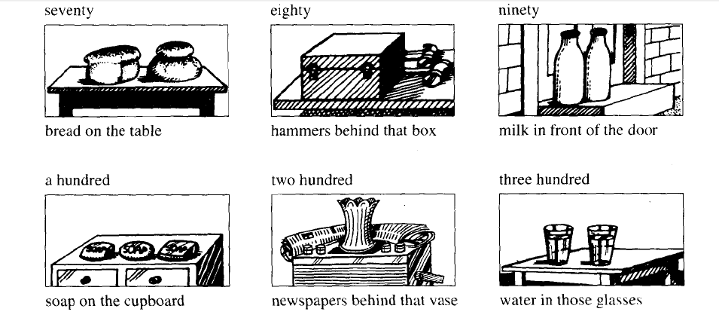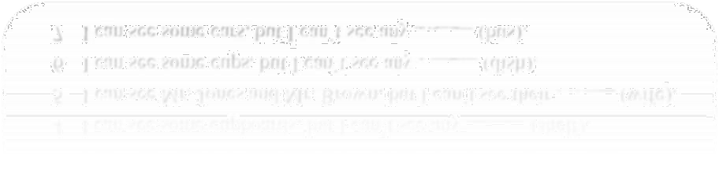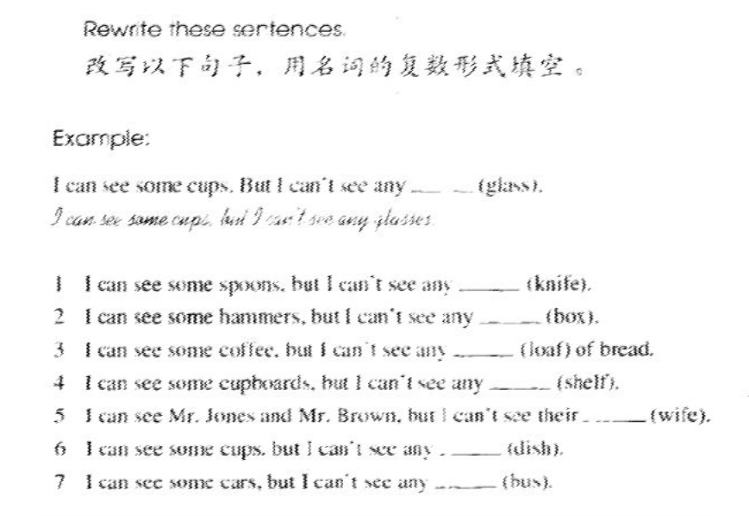

Are there any…? Is there any…? Are there any + Is there any +

Are there any + 复数可数？

Is there any + 不可数？

# Lesson 43&44 知识拓展

有

1. 拥有：have
2. 存在：there is\are

你有…吗？Do you have…?

那有…吗？Is there …? +单数

Are there …? +复数你有男朋友吗？

Do you have a boyfriend?

那有银行吗？ Is there a bank？ 那有水吗?

Is there any water? 那有很多树吗？ Are there any trees? 你有钱吗？

Do you have any money?

那有很多楼吗?

Are there any buildings?

